Task 3 Report: Advanced CSS Styling and Responsive Design

Objective
The objective of this task is to enhance the visual appearance of the webpage by applying advanced CSS styling techniques and to ensure the webpage is fully responsive across different screen sizes.
This task focuses on improving layout structure, user experience, and consistency by using modern CSS features and a CSS framework.

Tools and Technologies
- HTML – Used to structure the webpage into multiple sections.
- CSS – Applied for advanced styling, animations, and responsiveness.
- Bootstrap (CSS Framework) – Used to build a consistent, responsive, and mobile-friendly user interface.
- Browser Developer Tools – Used to test responsiveness across different screen sizes.

Procedure

Step 1: Creating a Complex Layout
- The webpage was divided into multiple sections such as:
  - Header / Navigation bar
  - Main content section
  - Form or information section
  - Footer
- Each section was structured to clearly separate content and improve readability.
- A grid-based layout was used to align elements properly and maintain consistency.

Step 2: Advanced CSS Styling
- Advanced CSS properties were applied to enhance the visual appearance:
  - Font styling for better readability
  - Background colours and gradients for visual depth
  - Borders, padding, and margins for proper spacing
- Cards, buttons, and form elements were styled to create a professional UI look.
- Consistent colour themes were maintained throughout the webpage.

Step 3: CSS Transitions and Animations
- Smooth CSS transitions were added to interactive elements such as buttons and links.
- Hover effects were applied to improve user interaction feedback.
- Basic CSS animations were used to enhance visual engagement without affecting performance.
- These effects made the webpage more dynamic and user-friendly.

Step 4: Responsive Design Implementation
- The layout was tested on multiple screen sizes including:
  - Desktop
  - Tablet
  - Mobile
- Flexible layouts were used so that elements automatically adjust according to screen width.
- Text, images, and buttons resized smoothly for smaller screens.
- Navigation and content sections stacked vertically on mobile devices for better usability.

Step 5: Using CSS Framework (Bootstrap)
- Bootstrap was used to ensure consistency and responsiveness.
- Bootstrap components such as:
  - Grid system
  - Responsive containers
  - Buttons and cards
  - Navigation bar
were utilized.
- The framework helped maintain uniform spacing, alignment, and responsiveness across devices.
- Bootstrap significantly reduced manual styling effort while maintaining a professional design.

Observations
- Advanced CSS styling improved the overall visual appeal of the webpage.
- Transitions and animations enhanced user interaction.
- The webpage responded well across all screen sizes.
- Bootstrap provided a consistent and responsive UI with minimal effort.
- The combination of custom CSS and Bootstrap created a balanced and modern design.

Screenshots
Desktop View
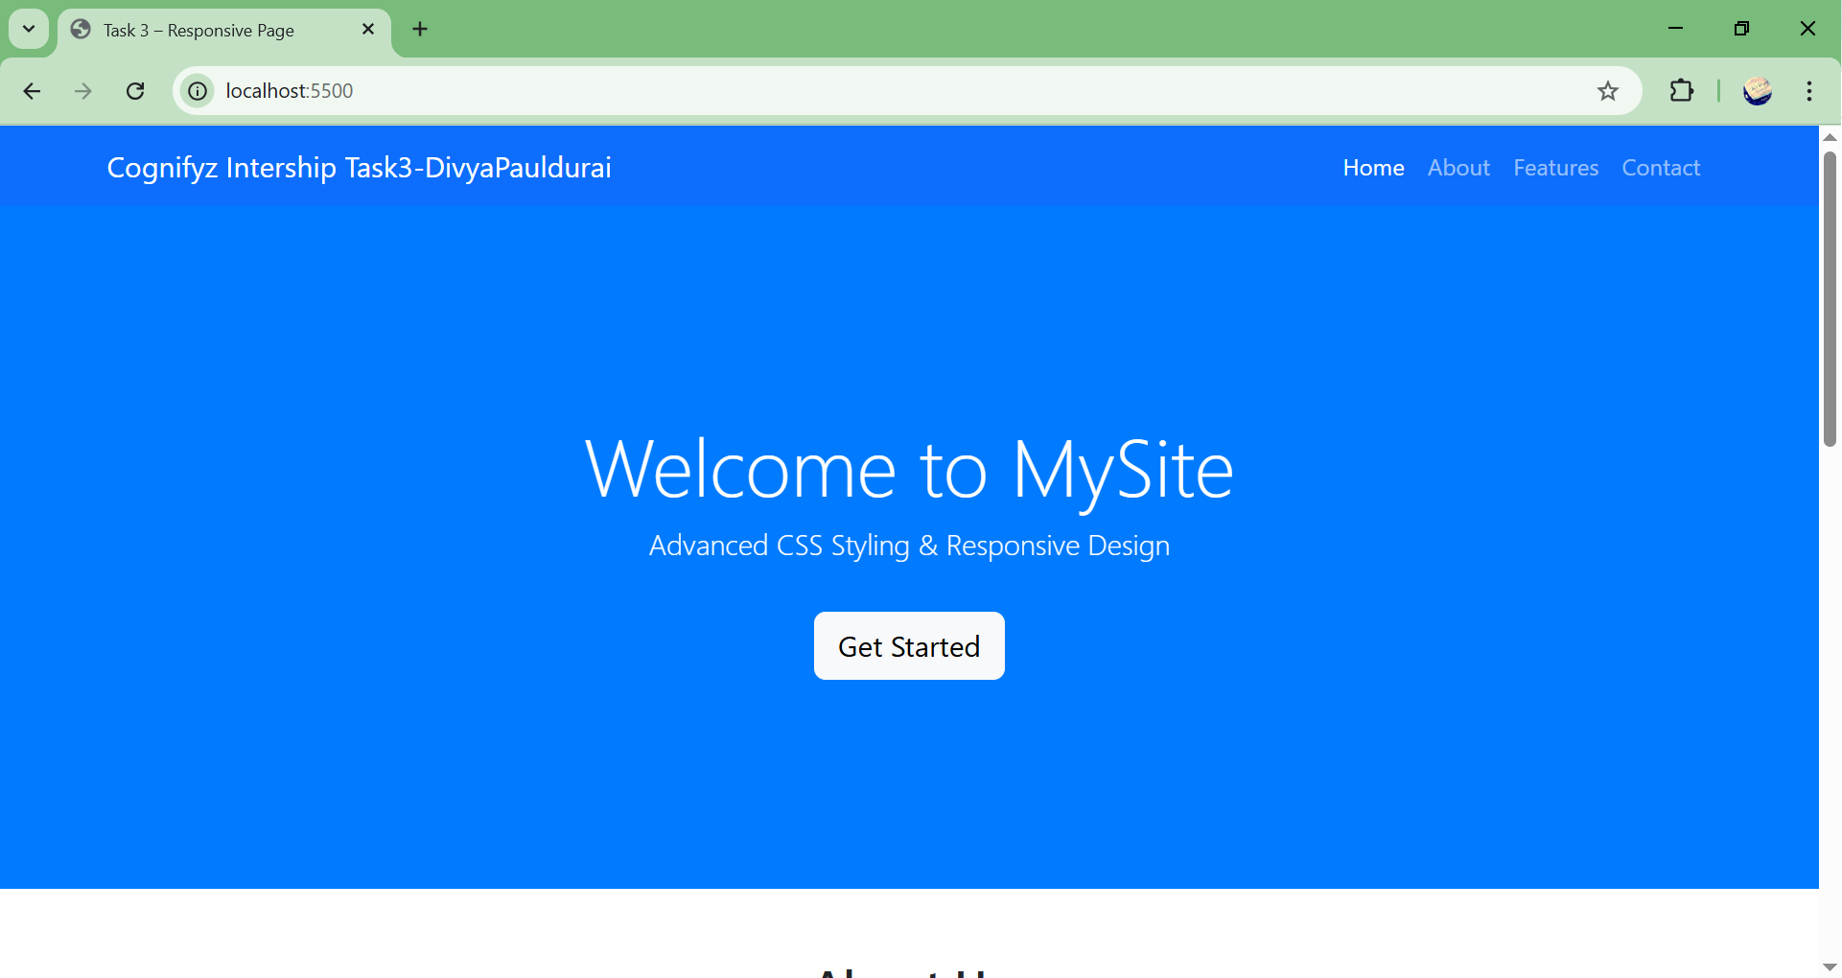
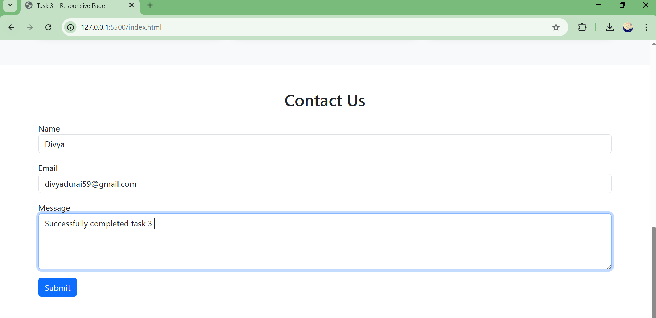

Conclusion
This task successfully demonstrates:
- Implementation of advanced CSS styling techniques.
- Creation of a multi-section layout for better content organization.
- Use of CSS transitions and animations for improved user interaction.
- Development of a fully responsive webpage using Bootstrap.
The task highlights the importance of responsive design and modern CSS in building user-friendly and visually appealing web applications.

